ASSINGMENT – 06

CURSOR OPERATION

Create Table

create table emp1(emp_id number,emp_name varchar(20),basic_pay number,con_pay number,tax number,net_sal number);

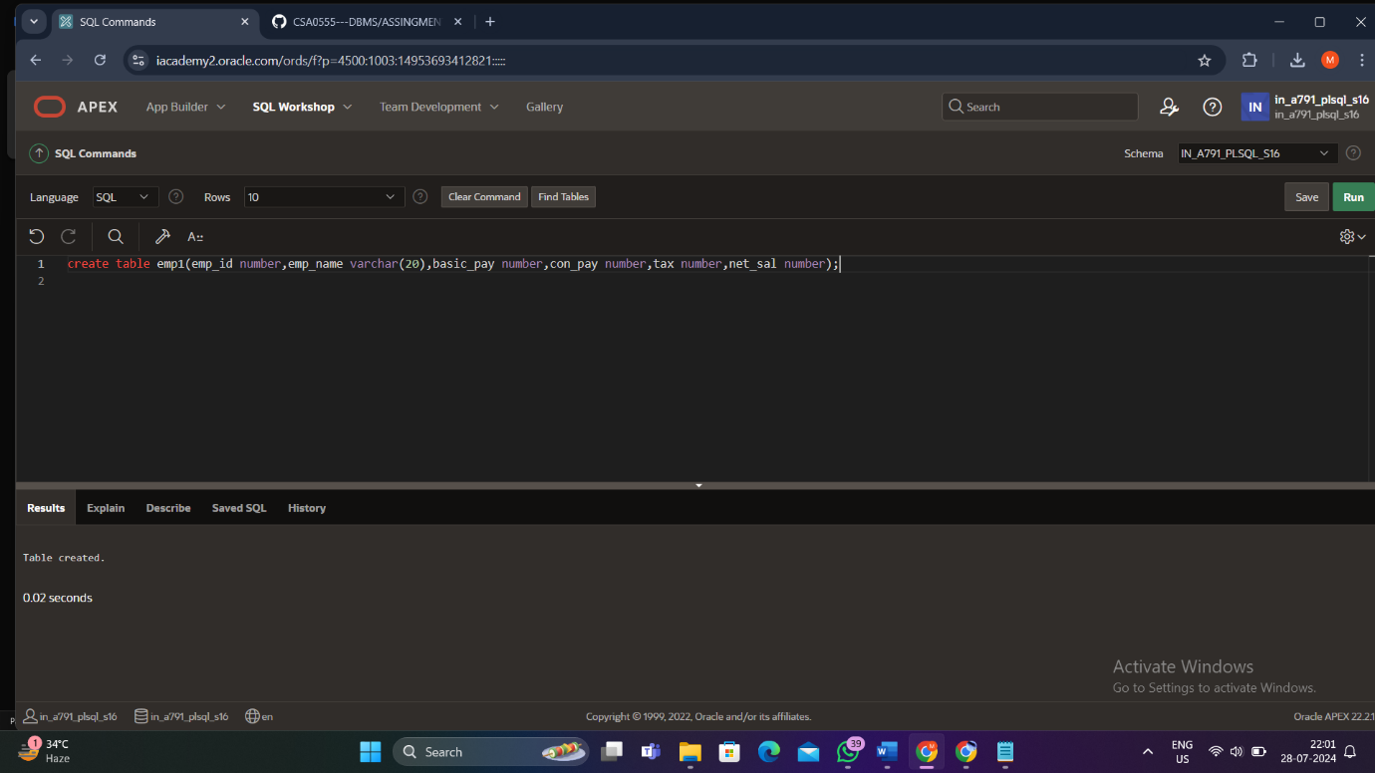

INSERT VALUES

insert into emp1 (emp_id,emp_name,basic_pay)values(100,'aaa',30000);

insert into emp1 (emp_id,emp_name,basic_pay)values(101,'bbb',40000);

insert into emp1 (emp_id,emp_name,basic_pay)values(102,'ccc’,50000);

insert into emp1 (emp_id,emp_name,basic_pay)values(103,'ddd',45000);

insert into emp1 (emp_id,emp_name,basic_pay)values(104,'eee',55000);

insert into emp1 (emp_id,emp_name,basic_pay)values(105,'fff',60000);

DECLARE

DECLARE

CURSOR cempl IS SELECT * FROM empl;

BEGIN

FOR e IN cempl LOOP

IF e.basic_pay = 30000 THEN

UPDATE empl

SET tax = 0.1 * e.basic_pay

WHERE emp_id = e.emp_id;

ELSIF e.basic_pay > 30000 THEN

UPDATE empl

SET tax = 0.2 * e.basic_pay

WHERE emp_id = e.emp_id;

END IF;

END LOOP;

END;

/

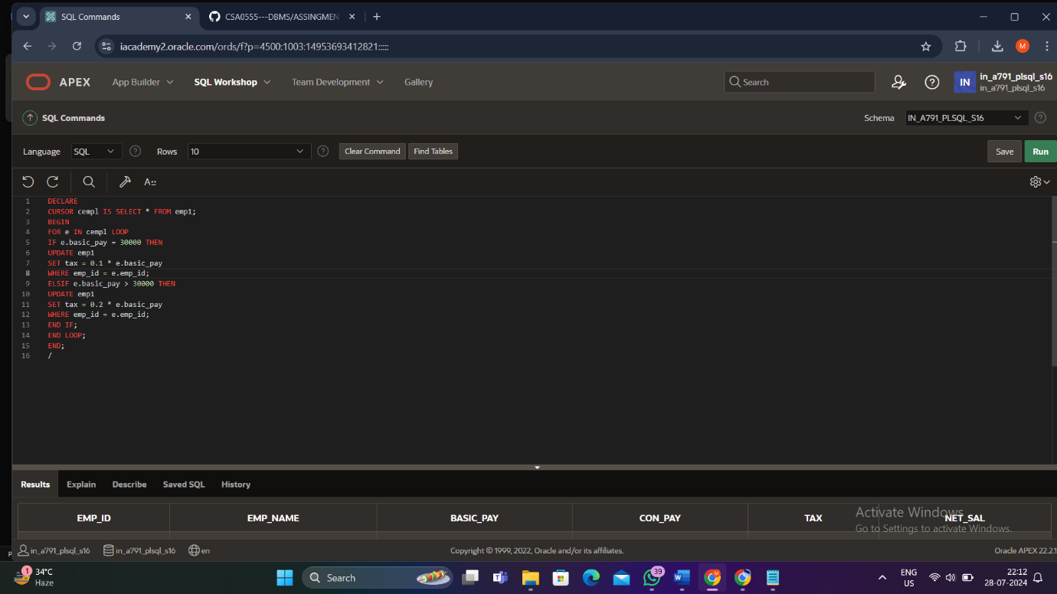

Display Table

Select * from emp1

